Toddler Bed Plans
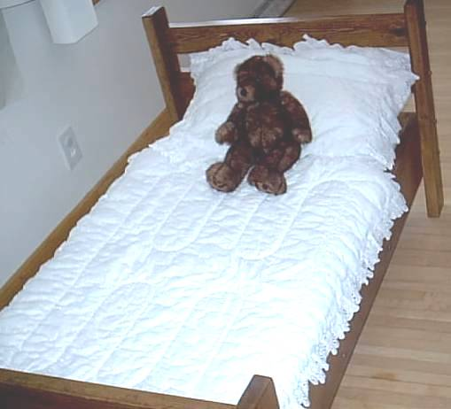
When our girl was a little over 1 year old, she started climbing out of her crib, creating a potential for a dangerous fall. So, I went looking for a nice low toddler bed. What I found was of such bad quality I wondered if the bed would even last as long as my daughter would need it. Since I already built bunk beds, I thought the toddler bed would not be too difficult to build. What I discovered is that the toddler bed was incredibly easy to build, was/is very sturdy, and cost around $35 to build. In addition, all the materials for this bed will fit in a small hatchback economy car. We used this bed for two of our children and are now giving it to another family! Here are the plans:
Raw Materials
(4) eight-foot 2x4’s
(2) eight-foot 2x8’s
2 1/2 inch deck/drywall screws and #10 finish nails
(1) 4ft by 4ft sheet or (3) 2ft by 4ft panels of 1/2” Plywood
(20) 3/8” wood plugs
(1) pound #10 finish nails
Wood Filler
Sandpaper and desired stain & varnish to finish

Step 1 - Cut each 8-ft 2x8 into lengths of 55 1/2" and 28" . Construct a box as shown below in fig-1. that has finished dimensions 55 1/2" by 30 7/8". Note: The thickness of the 2x8 was just a slight bit under 1.5 " so I have the finished width as 30 7/8". Your width may be slightly more. Don't worry about screw holes - the area you are fastening will be covered. Sand the top and outside before proceeding to the next step.
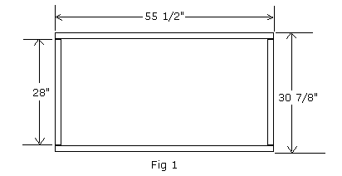

Step 2 - Cut (4) 28" pieces of 2x4 and fasten them within the 2x6 box as shown below. These will serve as the mattress supports. Fasten the 2x4's so they are flush with the bottom of the 2x6 frame. Place 2 of the pieces at the ends and fasten the other 2 pieces 18" from each end. After the bed is done, you will place plywood over these 2x4 support pieces.

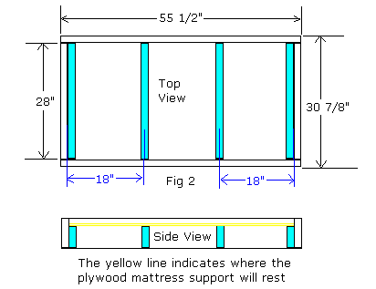
As can be seen on the left, the 2x4's are attached to the 2x6 frame so they are flush with the bottom. There are (4) 2x4's although one is not showing. Attach the two end 2x4's from the inside with deck/drywall screws and you will have no nail holes to deal with.

To conceal where the two middle supports are fastened, drill out a shallow hole for a 3/8" wood plug and then fasten with a deck screw - then cover with a wood plug as shown to the left in the bottom photo. Also secure with several long (#10) finish nails and set and fill with wood filler.
Step 3 - Cut (2) 27 3/4" and (2) 20 1/2" pieces of 2x4 for the corner posts. Sand these pieces. Then, fasten these on the corners as shown below.

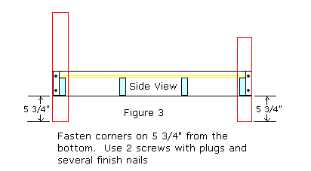

Step 4 - Cut (3) headboard pieces that should be about 31 7/8" - you need to measure the exact distance from the inside of one corner to the other. Due to slight variations in lumber, this measurement may be slightly larger or smaller than 31 7/8". Sand these pieces. Then, fasten pieces as shown below with 1 screw (covered with a wood plug) and several finish nails at each location.
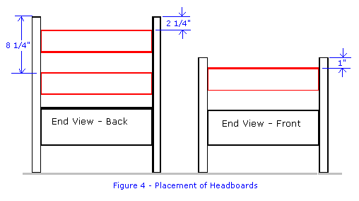
Step 5 - Cut mattress support pieces out of 1/2 inch plywood and fasten with deck/drywall screws. If you want this support in 1 piece, you will need a full 4x8 sheet of plywood. Otherwise, you can cut out 3 pieces as shown below from a 4x4 piece or use (3) 2ftx4ft plywood panels. Fasten the plywood with screws so you can remove it easily.
Step 6 - Finish as desired. My wife liked the dark finish pictured (and she calls the shots in the nursery!) but my personal preference is a natural stain/sealer by Mini-wax with a satin finish polyurethane. You can use any standard crib mattress with this bed.

